

Family Engagement Plan for Pre-Kindergarten

Early Childhood – ELAR Department

2021-2022

Parental involvement plays a large factor in early childhood student success. In order to support parents and provide them with ideas and strategies to support their child’s literacy achievement, DISD hosted the following series of sessions for parents during the 2021-2022 school year.

These sessions were developed around materials from “Partners in Print,” a parent-involvement program for beginning readers. The aim of this program is to educate and empower parents so they can help develop their children’s literacy and encourage partnership between parents, teachers, and children.

The dates and times for the 2021-2022 school year were as follows (some campuses made adjustments to the dates and still covered the topics). The hours for the sessions were 5:30-6:30 p.m. at each respective campus.

* September 28th – Opening Night (Program Introduction), 5:30 p.m.-6:30 p.m.
* November 9th – Build Self-Esteem
* December 14th – Drawing Meaning From Text
* February 15th – Playing With Print
* March 22th – Conventions of Print
* April 19th – Writing
* May 17th – Grand Finale

**BOARD OF TRUSTEES**

**Dr. Maricela Valdez**

President

**David De Los Rios**

Vice-President

**Jose L. Valdez**

Secretary

**Members**

Fernando Castillo

LTC(R) Robert Perez

Jose Rogelio Reyna, Jr.

Eva Castillo Watts

**ADMINISTRATION**

**Anthony Sorola, Ed.D.** Acting Superintendent

**Debra A. Aceves, Ph.D.**

Assistant Superintendent for Sec. Leadership

**Rebecca Castaneda**

Assistant Superintendent

for Elem. Leadership

**Rashad J. Rana**

Assistant Superintendent of Curriculum and Instruction

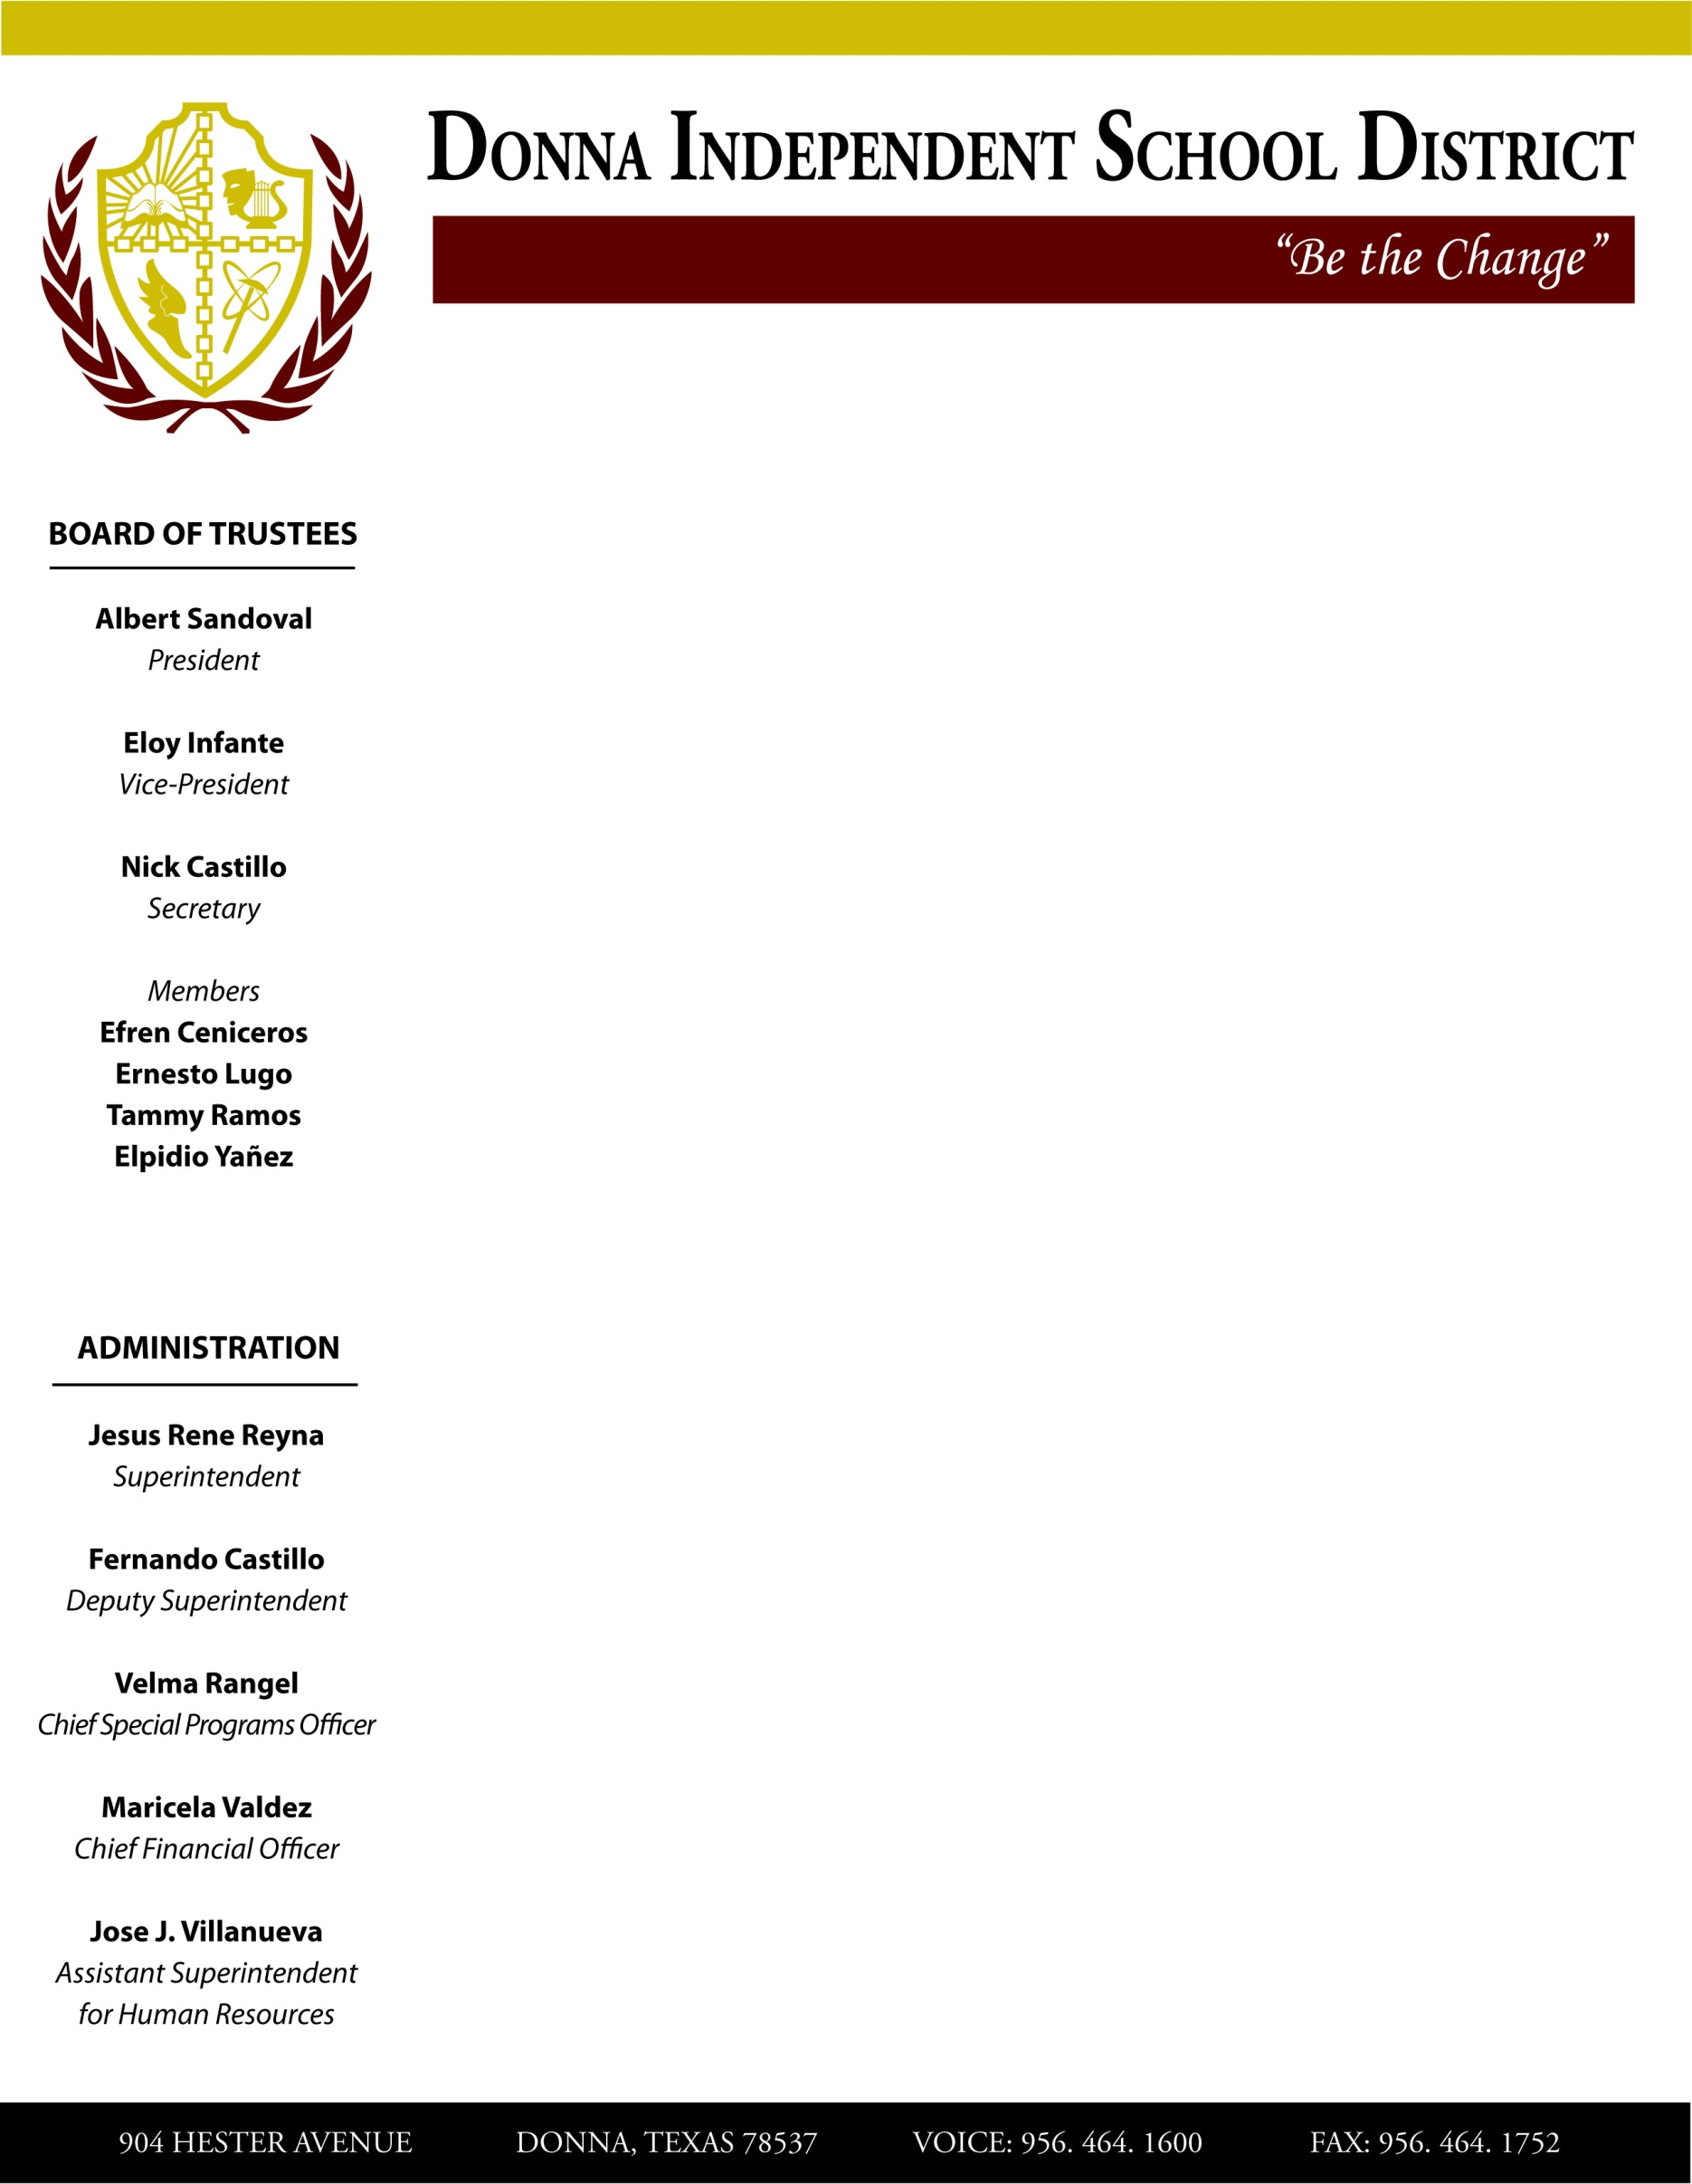

904 HESTER AVENUE DONNA, TEXAS 78537 VOICE: 956-464-1600 FAX: 956-464-17522